**Bearcat Job Search**

Software Requirements Specification

Version: 1.0.6

November 08, 2020

Team Members

Anil Bomma

Yugandhar Rao Mamidi

Prasanna Kumar Potnuru

Santhosh Kumar Bollena

Sai Chandu Gampa

Mahendar Reddy Surkanti

Submitted in partial fulfilment

Of the requirements of

CSIS 44-691 Graduate Directed Project 1

# Revision History

|  |  |  |  |
| --- | --- | --- | --- |
| **Date** | **Description** | **Author** | **Comments** |
| June 10, 2020 | Added project introduction | Anil Bomma,  Sai Chandu Gampa | Added chapter – 1 introduction. |
| June 10, 2020 | Added project general description | Yugandhar Rao Mamidi,  Mahendar Reddy Surkanti | Added chapter – 2 General Description. |
| June 10, 2020 | Added project requirements | Santhosh Kumar Bollena,  Prasanna Kumar Potnuru | Added chapter – 3 Specific and functional requirements. |
| June 10, 2020 | Added ER diagram | Santhosh Kumar Bollena,  Mahendar Reddy Surkanti | Designed ER diagram. |
| June 11, 2020 | Added description for ERD and Created Mockups | Yugandhar Rao Mamidi, Prasanna Kumar Potnuru, Sai Chandu Gampa | Added prototypes under GUI |
| June 16, 2020 | Added few more requirements | Anil Bomma, Prasanna Kumar Potnuru, Santhosh kumar Bollena | Added Live chat and Search option in the application. |
| November 08, 2020 | Documentation | Everyone | Technical manual, End-user manual |

# Document Approval

The following Software Requirements Specification has been accepted and approved by the following:

|  |  |  |  |
| --- | --- | --- | --- |
| **Signature** | **Printed Name** | **Title** | **Date** |
| WhatsApp Image 2020-06-09 at 3 | Yugandhar Rao Mamidi | Mr. | June 10, 2020 |
| prasusign | Prasanna Kumar Potnuru | Mr. | June 10, 2020 |
| chandusign | Sai Chandu Gampa | Mr. | June 10, 2020 |
| anilsign | Anil Bomma | Mr. | June 10, 2020 |
| santhoshsign | Santhosh Kumar Bollena | Mr. | June 10, 2020 |
| mahisign | Mahendar Reddy Surkanti | Mr. | June 10, 2020 |

**Table of Contents**

**Table of Contents Page Number**

1. Introduction
   1. Purpose
   2. Scope
   3. Definitions, Acronyms, and Abbreviations
   4. References
   5. Overview
2. General Description
   1. Product Perspective
   2. Product Functions
   3. User Characteristics
   4. General Constraints
   5. Assumptions and Dependencies
3. Specific Requirements
   1. External Interface Requirements
      1. User Interfaces
      2. Hardware Interfaces
      3. Software Interfaces
      4. Communications Interface
   2. Functional Requirements
   3. Use Cases
   4. Class/Objects
   5. Non-Functional Requirements

3.5.1. Performance

3.5.2. Reliability

* + 1. Availability
    2. Security
    3. Portability
  1. Inverse Requirements
  2. Design Constraints
  3. Logical Database Requirements
  4. Other Requirements
  5. Prototypes (for complete project)
  6. Use Case Diagrams

1. Design

4.1. ER diagram

4.2. GUI

1. Analysis Models

4.1. Data Flow Diagram

4.2. Sequence Diagram

1. Technical Manual

6.1. UI Templates (Front-end)

6.2. API’s (Back-end)

7. End-user Manual

7.1. Registration Page

7.2. Login Page

7.3. Forgot Password Page

7.4. Change Password Page

## CHAPTER – 1

**INTRODUCTION**

* 1. **Purpose**

At Northwest Missouri State University we have a career-center office were students update their resume in a professional way for better opportunities in the job market. But as of now at Northwest, we don't have any job portal or job searching application, and every time when the recruiters want to hire students they have to reach the particular department head at the university. In order to communicate with the students and to inform them about the job opportunity, the department head has to send the mail to everyone.

These things make difficult to hire any students to solve all the above problems we have decided to build a web-application “Bearcat Job Search” were student can upload their profile and search the relevant jobs based on their degree.

* 1. **Scope**

Initially, the student has to register in the Bearcat Job Search application, after the registration, they have login in order to access the application and has to update their profile such as name, experience, knowledge on software programming languages or software tools, the average salary expectation like so. Student can also upload their resume and integrate their GitHub or Linked-in account into their profile.

Recruiters can be accessed the Bearcat Job Search application once they are added by Admin. Once they have added to the system, they can check for student's profile and they can filter based on their requirements specifications such as Front-end developer, Back-end developer, Full-stack developer, DBA, Dev-Ops, Chemist, Agriculture, HR, Business Management, etc.

* 1. **Definitions, Acronyms, and Abbreviations**

The following terms, acronyms, and abbreviations are used throughout this document.

**Admin**: Admin is the super user, how has complete access to the application.

**Recruiters**: These are the hiring team and they can view all student's profiles and can download students' resumes.

**Student**: Student refers to job seekers, they can search for the relevant jobs and can apply to them if they are interested and can also make those jobs as a favorite for the future use or reference.

**GitHub**: GitHub brings together the world's largest community of developers to discover, share, and build better software.

**Linked-in**: Manage your professional identity. Build and engage with your professional network. Access knowledge, insights, and opportunities

* 1. **References Scope**
* https://www.linkedin.com/
* https://www.indeed.com/
* https://www.monster.com/
* https://www.careerbuilder.com/
* https://www.glassdoor.com/index.htm
  1. **Overview**

Bearcat Job Search application can provide lots of opportunities to find numerous jobs on their degree, work experience, and help the students to get their dream job. As well as the Recruiters are also benefited by filtering out there students based on the profile and work experience, and this application makes it so much easy to communicate with the candidate by providing live chat.

CHAPTER – 2

GENERAL DESCRIPTION

1. **Product Perspective**

The main perspective of the Bearcat Job Search application is to be helpful to the recruiters and students in finding their employee and employers respectively.

1. **Product Functions**

As a part of organizing, we have divided the tasks among the team members and planned to conduct recursive team meetings daily to know the daily progress of the assigned tasks.

1. **User Characteristics**

The user of the application will be provided to access the application in different ways, one is through student and another is a recruiter. Students first need to register under the registration page in order to view the job posting and upload their respective resumes or CVs. If a recruiter wants to access the application first they should get permission from the admin through email, So that each recruiter will be provided with a unique email id and password to view and access the profile of the students.

Students are also provided to edit and update their profiles on daily basis. They can also search the jobs based on technologies and designations.

1. **General Constraints**

In order to develop the application, we have formed into a team of 6 members and divided the tasks and planning to complete the project in six months. As a part of the submission, the deadline for phase-1 is mid of June 2020.

In order to complete the project on time. We fixed deadlines through frequent zoom meetings.

1. **Assumptions and Dependencies**

As a project plan. Firstly we are gathering all the requirements necessary for the project development and then planned to design ER-Diagram to represent the entity relations between the models. Further, the tasks are divided as follows:

* Initial project set up for frontend and backend in GitHub.
* Team will write the migration script where all the database schema from the ER diagram will be created automatically from the migration script.
* Creating Models for the Project.
* Implementing authentication logic in the backend for login functionality.
* Creating API for registration and login form in back-end.
* Designing UI Registration Page for Students.
* Designing UI Login Page for Admin, Recruiter, and Student.
* Testing and Debugging the Application with login and registration functionality.

CHAPTER – 3

SPECIFIC REQUIREMENTS

* 1. **External Interface Requirements**

* + 1. **User Interfaces** 
       1. **Registration Page:** Students will register to the application from a registration form.
       2. **Login Page:** Students, Recruiter, Admin can login to the application with this User Interface.
       3. **Forgot Password Page:** Students can retrieve their password here.
       4. **Student Welcome Home Page:** All the job postings from recruiter and admin will be listed over here. Students will have a search bar to search from the jobs posted.
       5. **Recruiter Home Page:** All the students will be displayed in tabular format. Recruiters can search the student based on the interested position of the student or based on name.
       6. **Student Profile Page:** Student profile page where a student can edit their profile details.
       7. **Recruiter Profile Page:** Recruiter profile page where recruiter can edit their profile details.
       8. **Display Resume Page:** Where Recruiter and Admin can view the resume of the student and can download it.
       9. **Admin Add Recruiter:** Admin can add new Recruiter here.
       10. **Add New Job Post:** Admin and Recruiter can add new job post here.
       11. **Contact Us Page**: Details of the Admin will be displayed so that if a Recruiter or Student has any queries can contact the Admin.
       12. **FAQ Page:** Some frequently asked questions from the students and recruiters can be displayed over here.
       13. **Live Chat:** Through this, employee and employer/recruiter can communicate with each other.
       14. **Search:** Students or recruiters can search for a particular job or person in the Search bar.
    2. **Hardware Interfaces**

• Processor: Minimum 1 GHz; Recommended 2GHz or more

• Ethernet connection (LAN) OR a wireless adapter (Wi-Fi)

• Hard Drive: Minimum 32 GB; Recommended 64 GB or more

• Memory (RAM): Minimum 1 GB; Recommended 4 GB or above

* + 1. **Software Interfaces**

• Visual Studio Code

• Node JS

• React JS

• MySQL Workbench

• Adonis JS

* + 1. **Communications Interface**

• Chrome

• Safari

• Firefox

* 1. **Functional Requirements**
     1. **Roles in the Application**
        + Admin
        + Recruiter
        + Student
     2. **Responsibilities of each role**
        1. **Admin**
           1. Admin can post job requests.
           2. Admin can edit and delete the posted job request.
           3. Admin can add Recruiter.
           4. Admin can search for the student based on their profile (Searching for Students interested in Full Stack Development).
           5. Admin can view all student profiles.
           6. Admin can view the Student Resume and if the admin wants to download it he/she can.
           7. Admin can edit Recruiter and Student profile details.
           8. Admin can view the students GitHub account.
           9. Admin can view the students LinkedIn account.
           10. Admin can send a mail to the student.
           11. Admin can live chat with students
        2. **Recruiter**
           1. Recruiter can post job requests.
           2. Recruiter can edit and delete the posted job request.
           3. Recruiter can search for the student based on their profile (Searching for Students interested in Full Stack Development).
           4. Recruiter can view all student profiles.
           5. Recruiter can view the Student Resume and if the recruiter wants to download it he/she can.
           6. Recruiter can view the students GitHub account.
           7. Recruiter can view the students LinkedIn account.
           8. Recruiter can send a mail to the student.
           9. Recruiter can live chat with students.
        3. **Student**
           1. Register into application to access the functionalities.
           2. Login to application using the login credentials from the registration form.
           3. Password retrieval can be done if the Student forgets their password.
           4. Students can update their details like (Name, alternate email, description, Experience, Salary expectation, etc...).
           5. Students can upload their resume in .pdf, .docx, .doc format.
           6. Students can search for jobs posted.
           7. Students can apply for the job he/she might interested in.
           8. Students can integrate GitHub profile into application.
           9. Students can integrate LinkedIn profile into application.

CHAPTER – 4

DESIGN

**4.1 ER Diagram**

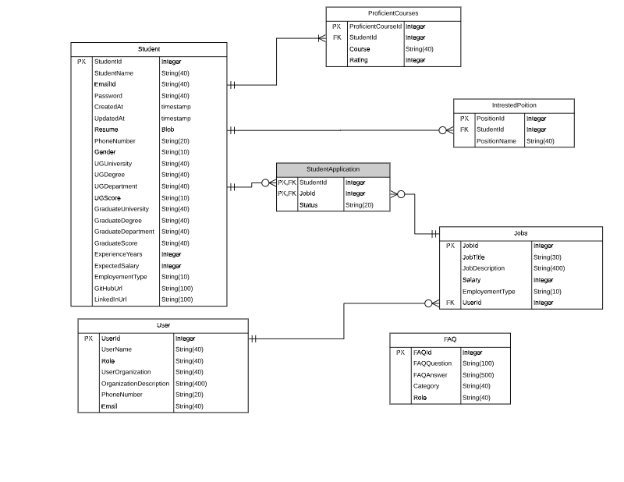

*Fig: 1 ER diagram for “Bearcat Job Search”*

From the Fig: 1, we have our ER-Diagram of “**Bearcat Job Search**” which includes entities: *Student, User, ProficientCourses, InterestedPosition, Jobs, FAQ*. In the Student entity we have many attributes like StudentID of type integer, StudentName of type String, etc. User entity have attributes like UserId of type integer etc. Similarly based on the type of the entity and model, consisting of all purposeful attributes as shown in the above diagram.

The relationship between the entities in the diagram differs from one another depending upon the constraints they have. Considering Student and ProficientCourses entities, the relationship is one to many because one student must have at least one or more ProficientCourses. And also one student can show interest in zero or more positions. Coming to Student and Jobs entities, we have an associative entity **StudentApplication** connecting both the entities in a relationship is Many to Many. In the associative entity, we have included both the keys (PK, FK) StudentId, JobId and also Status attribute of type string which tells the current status of the application. In the User entity, we have a special attribute named Role which can be Admin or Recruiter. Admin can delete or add jobs and Recruiter can also delete or add jobs upon successful access given by the Admin.

**4.2 GUI**

**Registration Page:**

This is a registration page where students can register by providing the details as mentioned in the image like firstname, lastname, email, password etc

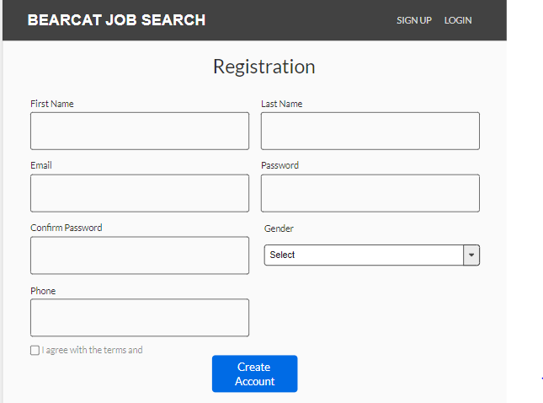

**Login Page:**

This is a login page, where students should enter their email and password details given in the registration page in order to view the job postings.

If the user has forgotten their password they can reset the password by clicking on “Forgot Password” link

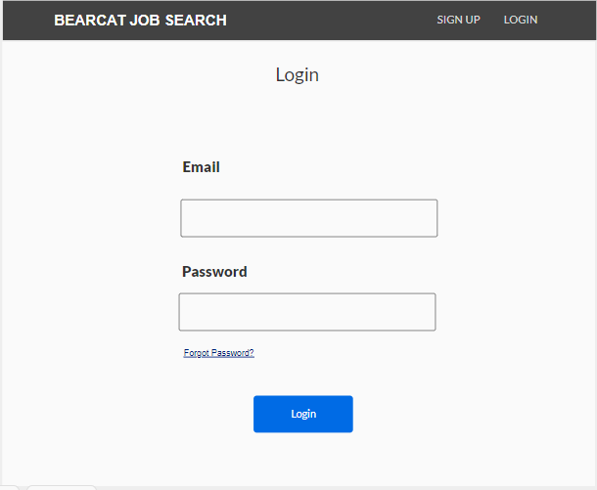

**Job Postings:**

This is a job posting page, where the student can view and apply the respective jobs based on job position and they can also view the total jobs applied

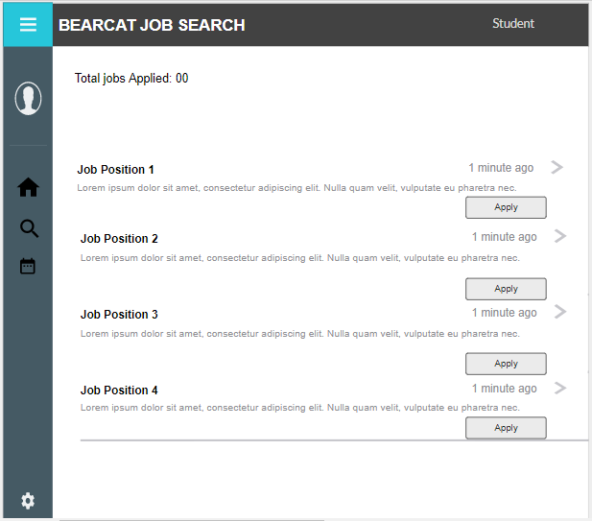

**Job Description:**

When the student clicks on the job position in the job posting page, they will be redirected to this page, where job position information, organization and description of the job can be viewed. If the student is interested in the job position then they can apply by clicking on “apply” button or else he can be navigated to previous page by clicking on “cancel” button

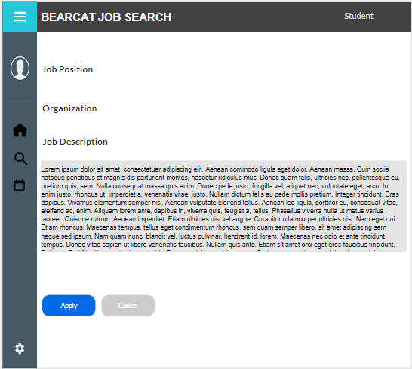

**Customer Request Form:**

This is a customer request form, where the user can enter their details and mention the issue with respect to accessing the page and their inputs regarding the application

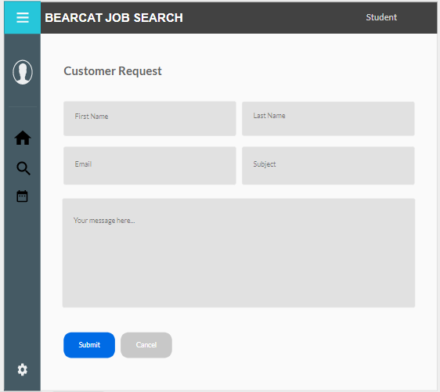

**Student Edit Profile:**

This is a student profile page, where the student can edit the profile and upload their updated resume and their expected salary as mentioned in the image

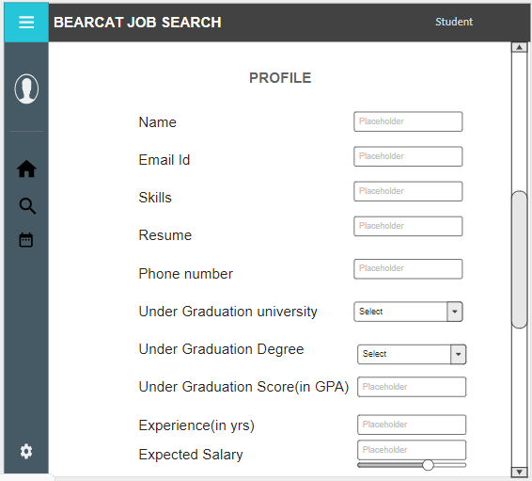

**Student Profile Access to Recruiter:**

This a student profile view of the recruiters where they can view the student detailed profile and view the resume through the text view option in order to know whether the student profile suits the recruiter vacant position or not

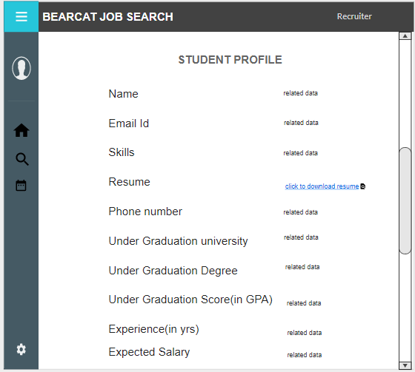

**Recruiter Access Rights Form:**

This is a recruiter access rights form where the admin has the right to give the permission to the recruiter to access the student profiles

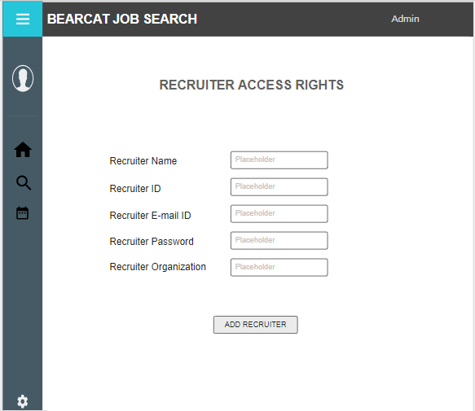

**Students Listing Form:**

The admin has the access to edit or delete the students by performing background checks on the student profiles whether student profile is genuine or not

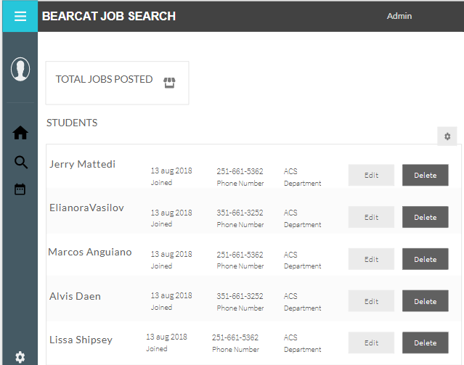

**Student Profile Information for Recruiter:**

This is a page for recruiter to view the student profiles, they can view the student profiles by clicking on the “click to view” button

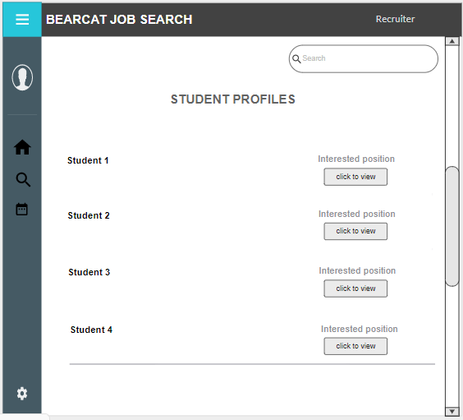

**CHAPTER 6**

**Technical Manual**

**6.1 UI Templates (Front-end)**

1. **Login Page:** We have made the below template for the login page. User needs to enter their User Name, Password and click on Login button. If they don’t have an account, they can directly click on the Register button and create an account.

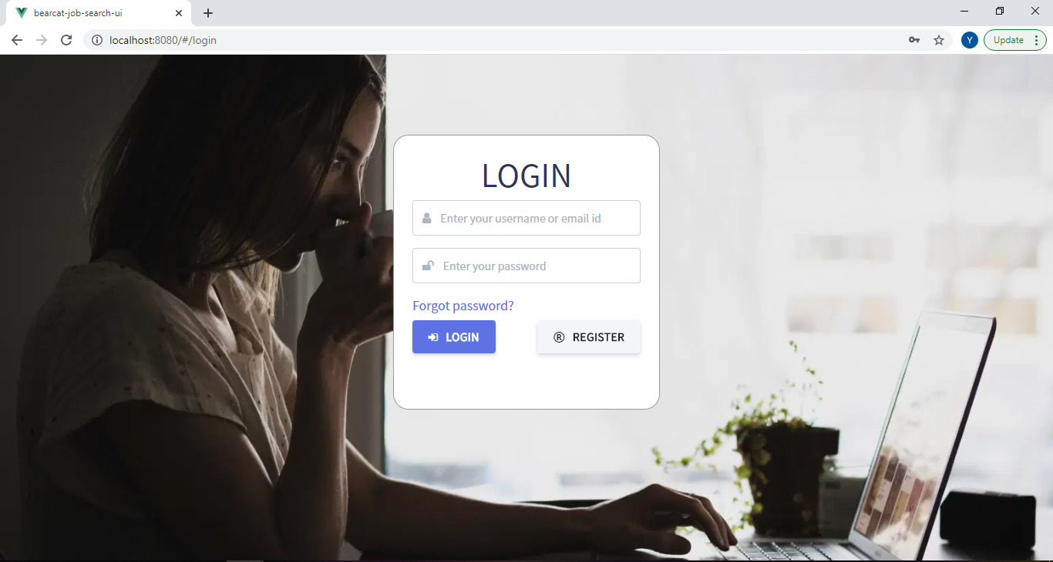

**Code:**

<template>

<div>

<div class="sidenav">

<div class="login-main-text">

<h2>

Bearcat Job Search

<br />Login Page

</h2>

<p>Login from here to access the application.</p>

</div>

</div>

<div class="main">

<div class="col-md-6 col-sm-12">

<div class="login-form p-3">

<form>

<div class="form-group">

<div class="input-group">

<span class="fa-stack fa-lg">

<i class="fa fa-square-o fa-stack-2x"></i>

<i class="fa fa-user fa-1x"></i>

</span>

<input

type="text"

class="form-control"

placeholder="User Name"

v-model="credentials.email"

/>

</div>

</div>

<div class="form-group">

<div class="input-group">

<span class="fa-stack fa-lg">

<i class="fa fa-square-o fa-stack-2x"></i>

<i class="fa fa-lock fa-1x"></i>

</span>

<input

type="password"

class="form-control"

v-model="credentials.password"

placeholder="Password"

/>

<br />

</div>

</div>

<button class="btn btn-primary mr-2" @click.prevent.stop="login">Login</button>

<router-link to="/register" class="border">

<button type="submit" class="btn btn-secondary">Register</button>

</router-link>

<div class="form-group mt-3">

<router-link to="/forgot-password" class="border">

<a>Forgot password?</a>

</router-link>

</div>

<Loader v-if="loader"></Loader>

<b-alert show variant="danger" v-if="error">{{error}}</b-alert>

</form>

</div>

</div>

</div>

</div>

</template>

**Explanation:** We have used basic tags like <div>, <h2>, <span> etc. For the User Name, we used <input> tag of type “text” and for the password of type “password”. Coming to the buttons, we used different types of classes of buttons like “btn btn-primary” for Login button and “btn btn-secondary” for Register button. We have also included some special “fa” class attributes like “fa-lock”, “fa-square-o” etc. for better look of the page.

1. **Registration page:** For the Registration page, we have made the below template. User needs to enter few details as clearly shown in the below picture. After filling all the details, they can click on Register button.

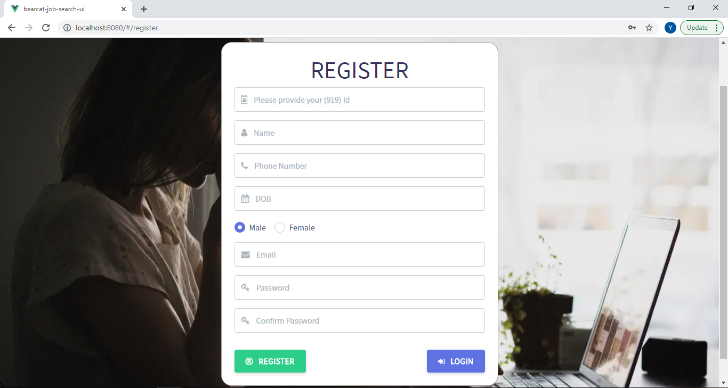

**Code:**

<template>

<div>

<div class="sidenav">

<div class="Registration-main-text">

<h2>

Bearcat Job Search

<br />Registration Page

</h2>

<p>Registration to access the application.</p>

</div>

</div>

<div class="main form-outline">

<section>

<div class="container">

<div class="row justify-content-center">

<div class="col-12 col-md-8 col-lg-8 col-xl-6">

<div class="row align-items-center mt-4">

<div class="col">

<div class="input-group">

<span class="fa-stack fa-lg">

<i class="fa fa-square-o fa-stack-2x"></i>

<i class="fa fa-user fa-1x"></i>

</span>

<input

type="text"

class="form-control"

placeholder="First Name"

/>

</div>

</div>

</div>

<div class="row align-items-center mt-4">

<div class="col">

<div class="input-group">

<span class="fa-stack fa-lg">

<i class="fa fa-square-o fa-stack-2x"></i>

<i class="fa fa-user fa-1x"></i>

</span>

<input

type="text"

class="form-control"

placeholder="Last Name"

/>

</div>

</div>

</div>

<div class="row align-items-center mt-4">

<div class="col">

<div class="input-group">

<span class="fa-stack fa-lg">

<i class="fa fa-square-o fa-stack-2x"></i>

<i class="fa fa-phone fa-1x"></i>

</span>

<input

type="text"

class="form-control"

placeholder="Phone Number"

/>

</div>

</div>

</div>

<div class="row text-left mt-4">

<div class="col">

<div class="form-check form-check-inline">

<input

class="form-check-input"

type="radio"

name="inlineRadioOptions"

id="inlineRadio1"

value="Male"

/>

<label class="form-check-label" for="inlineRadio1"

>Male</label

>

<span class="fa-stack fa-lg">

<i class="fa fa-circle fa-stack-1x"></i>

<i class="fa fa-male fa-stack-1x fa-inverse"></i>

</span>

</div>

<div class="form-check form-check-inline">

<input

class="form-check-input"

type="radio"

name="inlineRadioOptions"

id="inlineRadio2"

value="Female"

/>

<label class="form-check-label" for="inlineRadio2"

>Female</label

>

<span class="fa-stack fa-lg">

<i class="fa fa-circle fa-stack-1x"></i>

<i class="fa fa-female fa-stack-1x fa-inverse"></i>

</span>

</div>

</div>

</div>

<div class="row align-items-center mt-4">

<div class="col">

<div class="input-group">

<span class="fa-stack fa-lg">

<i class="fa fa-square-o fa-stack-2x"></i>

<i class="fa fa-envelope fa-1x"></i>

</span>

<input

type="email"

class="form-control"

placeholder="Email"

/>

</div>

</div>

</div>

<div class="row align-items-center mt-4">

<div class="col">

<div class="input-group">

<span class="fa-stack fa-lg">

<i class="fa fa-square-o fa-stack-2x"></i>

<i class="fa fa-lock fa-1x"></i>

</span>

<input

type="password"

class="form-control"

placeholder="Password"

/>

</div>

</div>

</div>

<div class="row align-items-center mt-4">

<div class="col">

<div class="input-group">

<span class="fa-stack fa-lg">

<i class="fa fa-square-o fa-stack-2x"></i>

<i class="fa fa-lock fa-1x"></i>

</span>

<input

type="password"

class="form-control"

placeholder="Confirm Password"

/>

</div>

</div>

</div>

<div class="row text-left mt-4">

<div class="col">

<div class="form-check">

<label class="form-check-label">

<input type="checkbox" class="form-check-input" /> I Read

and Accept <a href="#">Terms and Conditions</a>

</label>

</div>

<button class="btn btn-primary mt-4">Register</button>

</div>

</div>

</div>

</div>

</div>

</section>

</div>

</div>

</template>

**Explanation:** Used the similar tags for the Registration page. In addition, we have used radio buttons for the sex field using <input> tag of type “radio”.

Similarly, we have few similar pages like **Forgot Password**, **Change Password** pages if the user forgets or want to reset their password.

**6.2 API’s (Back-end)**

1. **Login Route Functionality:**

The following code has comments explaining each line of the login functionality.

**Overview:**

Whenever the user try to login with username and password this route will be activated and checks weather the username and password matches with the details of the database user.

//Login logic

async login({ request, auth, response }) {

//Getting the user data to login.

const userData = request.post();

//Veryfying weather the data has email and password for login.

if (!userData || !userData.email || !userData.password) {

return response.status(400).json({

error: {

status: 400,

message: "missing required feilds, email and password are required",

},

});

}

//Geeting the student based on email id.

let user = await Student.findBy("email", userData.email);

if (!user) {

return response.status(401).json({

error: {

status: 401,

message: "bad request, invalid email, password",

},

});

}

// checking hashed password for login

const hashedPassword = await Hash.verify(userData.password, user.password);

//If the password is incorrect sending an error with invalid password.

if (!hashedPassword) {

return response.status(403).json({

error: {

status: 403,

message: "invalid password..",

},

});

}

//Generating a JWT token for managing the application.

let token = await auth.generate(user);

user = await user.toJSON();

//Adding token to response object.

token = _.merge(token, {

message: "user login successfully",

studentId: user.studentId,

userId: user.userId,

email: user.email,

});

//Sending the succesful student details along with the access token.

return response.status(200).json(token);

}

1. **Registration Route Functionality:**

The following code has comments explaining each line of the registration functionality.

**Overview:**

Whenever the user try to register through the application, the application will validates the information and gives back the response accordingly.

//Registration logic

async registrationForStudent({ request, response, auth }) {

//Getting all the details from the registration form.

const student = request.all();

let err = [];

//Validation for all the feilds in the registration form.

if (!student.studentId) err.push("studentId is required");

if (!student.email) err.push("email is required");

if (!student.password) err.push("password is required");

if (!student.dob) err.push("dob is required");

if (!student.phoneNumber) err.push("phoneNumber is required");

if (!student.gender) err.push("gender is required");

//Cheaking for any missing feilds to send error as response.

if (err && err.length) {

return response.status(400).json({

error: {

status: 400,

message: "missing required parameters",

feilds: err,

},

});

}

//Hashing the password for security.

try {

const hashPassword = await Hash.make(student.password);

student.password = hashPassword;

//Storing the student details in database.

let studentInDB = await Student.create(student);

//Attaching succesful message for the response object.

studentInDB = _.merge(studentInDB, {

message: "student registered successfully",

});

//Returing the response object.

return response.status(200).json(studentInDB);

} catch (err) {

//Returning the error if the student is not stored.

return response.status(400).json({

error: err,

});

}

}

Technical Manual - **Prasanna Kumar Potnuru**

* Sending mails API
* Search Functionality UI/API

**Sending mails API:**

If a student forgot password to login, they can change the same clicking on Forgot Password? link and they will be redirected to Forgot password link, where they need to enter registered email for the link through mail.

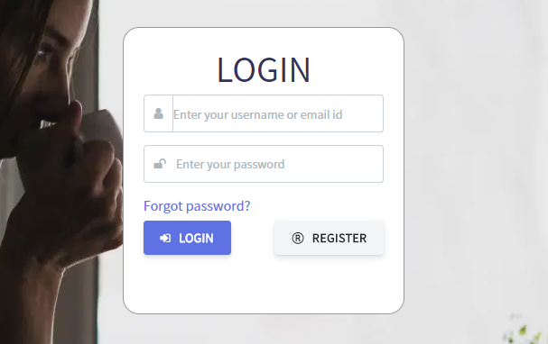

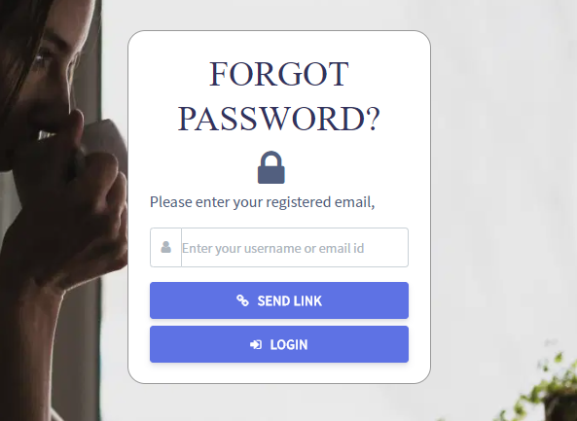

Below is the chunk of code for receiving the mail with reset password link.

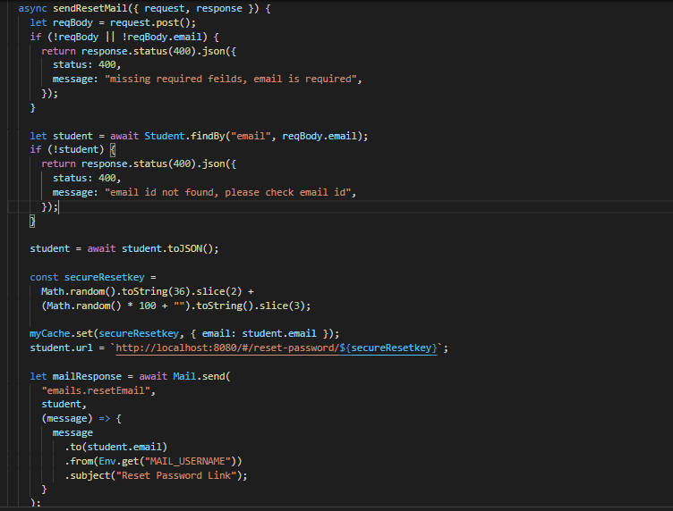

**Search Jobs UI:**

After a student’s successful login, they can find the Jobs in the navigation bar. For finding out a particular job based on Job name or description or some other filter quickly, they can search by entering the keyword.

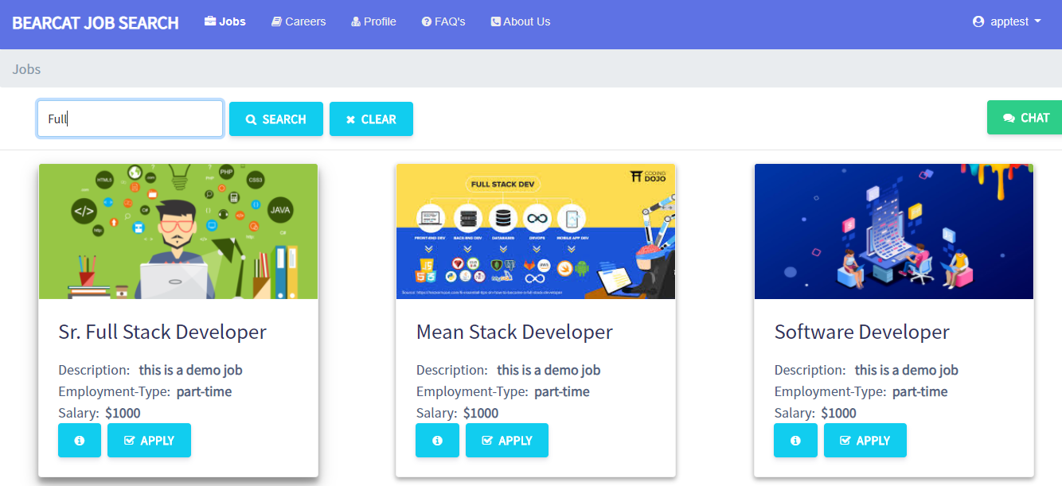

Clicking on Search button will get the matching criteria or jobs and also they can clear the filter using Clear button as shown

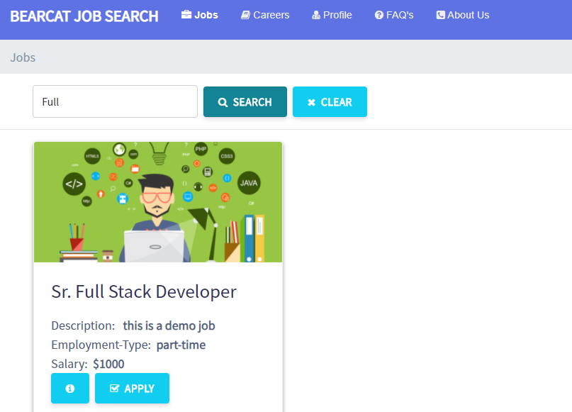

**Search Jobs connectivity & API:**

We have a method which will be called based on id given for the text box after clicking the search button. Below is the chunk of it.

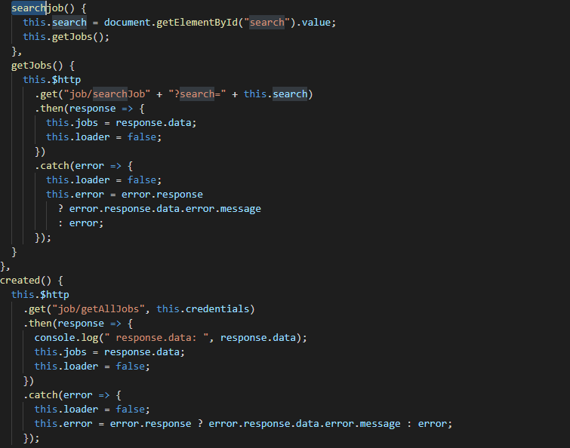

Below is the method defined in the Job controller for back-end route searching the jobs.

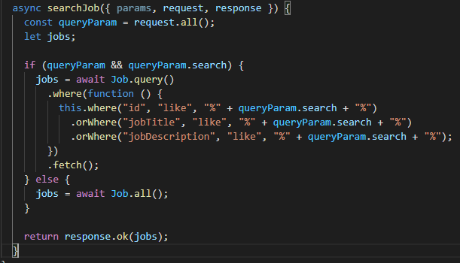

**Search Jobs UI in Careers page:**

If a student applies a job, they can find all the applied jobs in the Careers option. For finding out a particular applied job based on Job name or description or some other filter quickly, they can search by entering the keyword.

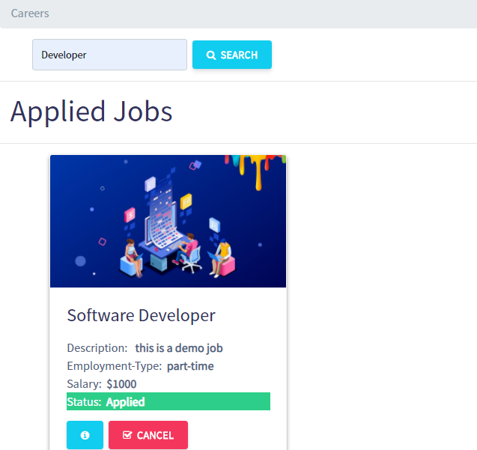

Coming to the functionality/API for careers page, we have defined the same logic as shown in the above screenshots.

**Search FAQs UI:**

If a student have a question, they can find all the frequently asked questions in FAQ’s page. For finding out a particular question based on a filter quickly, they can search by entering the keyword.

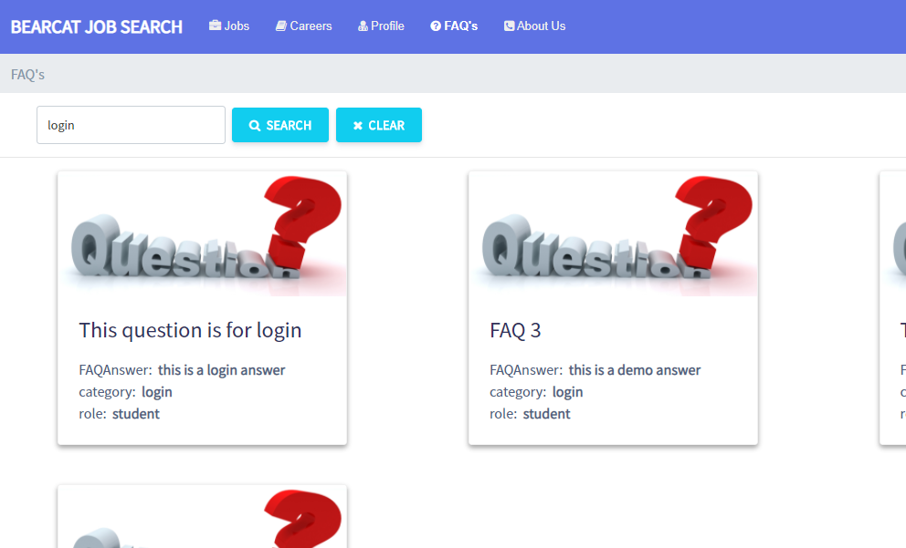

Clicking on Search button will get the matching criteria or questions and also they can clear the filter using Clear button as shown below.

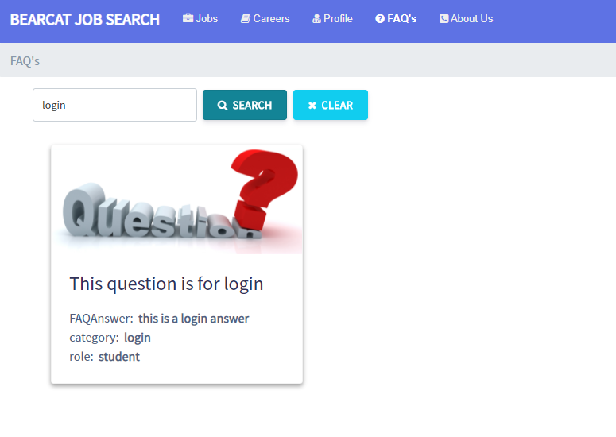

**Search FAQs connectivity & API:**

We have a method which will be called based on id given for the text box after clicking the search button. Below is the chunk of it.

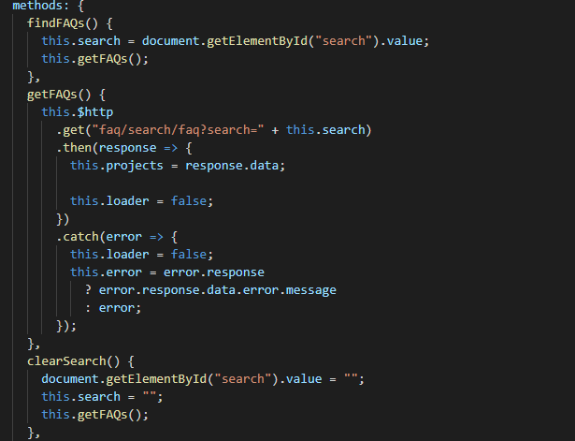

Below is the method defined in the FAQ controller for back-end route searching the FAQs.

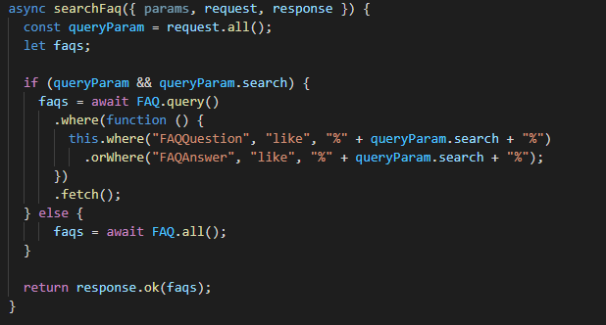

**Note**: Search functionality works same as mentioned above for Admin too.

**Technical Manual –Sai Chandu Gampa**

* CRUD Apply Jobs UI
* CRUD Apply Jobs API

**Apply Jobs CRUD UI:** ThisCRUD involves the below tasks.

**Apply Jobs:**

Student can apply a new job in the Jobs page.In the jobs page there is a apply button where the student will enter details and also can see the information about the organisation.

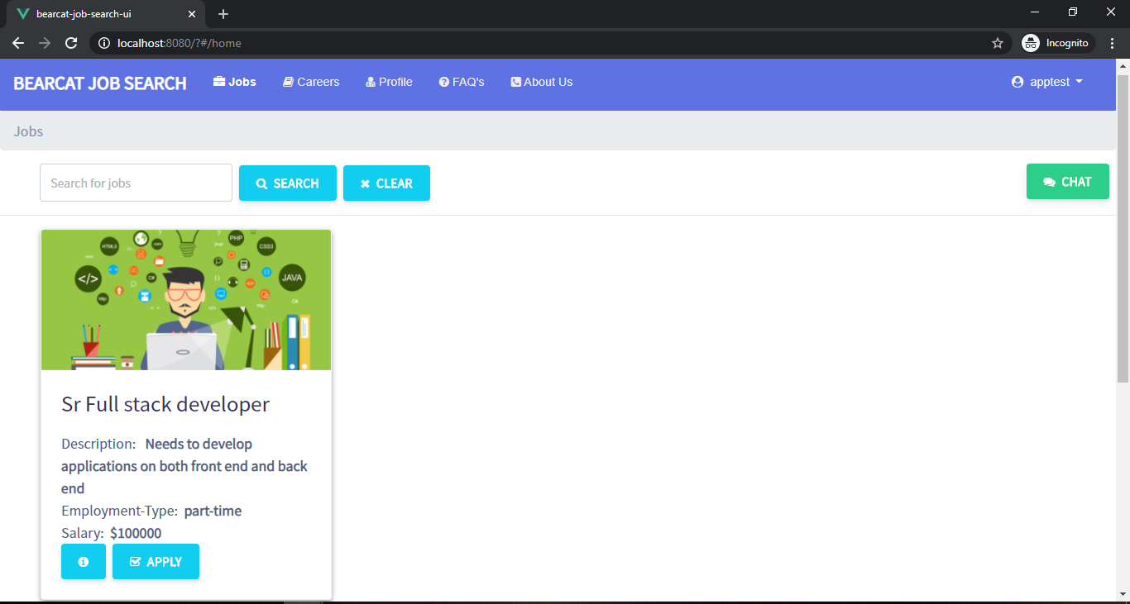

Student can see job info by clicking the button “ i” .All the information about job will be dispalyed .

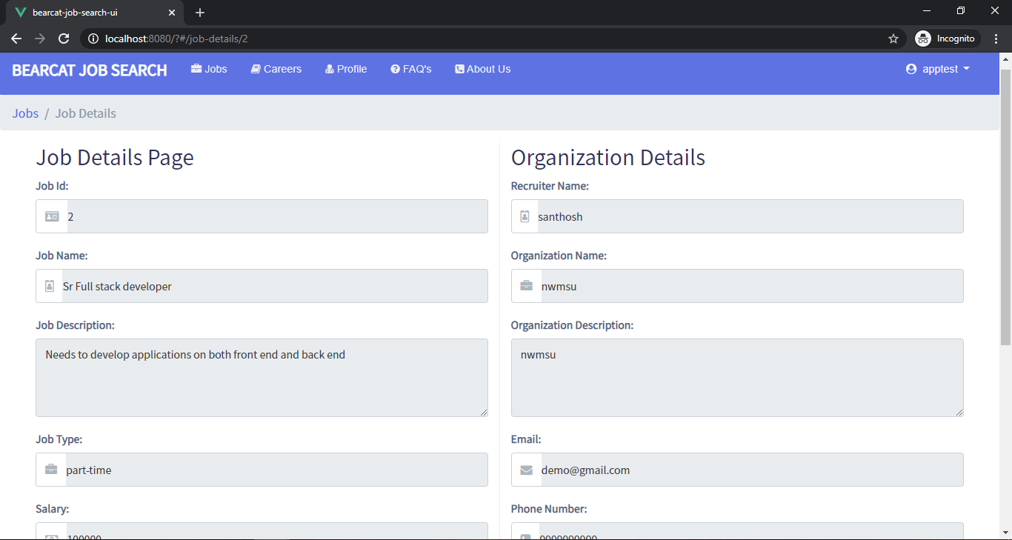

Afer clicking the apply button the student will be redirected to a page where he will apply for the job and can also see the job info.If the student want to cancel the applied job he can click on CANCEL button.

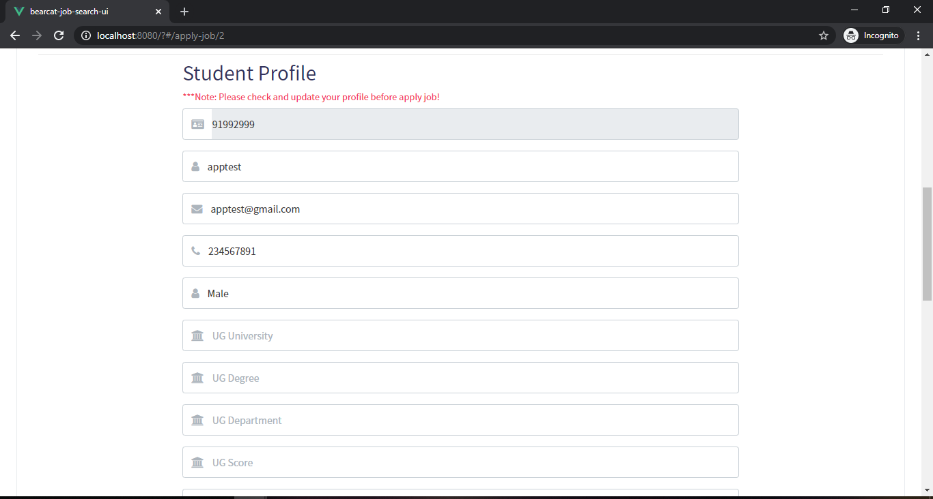

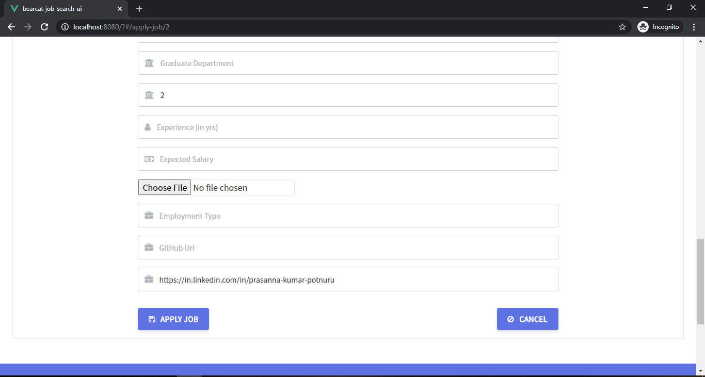

**Apply Jobs API**

**Code snippet for Student Jobs apply**

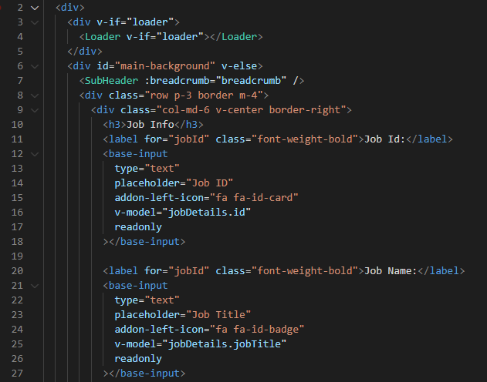

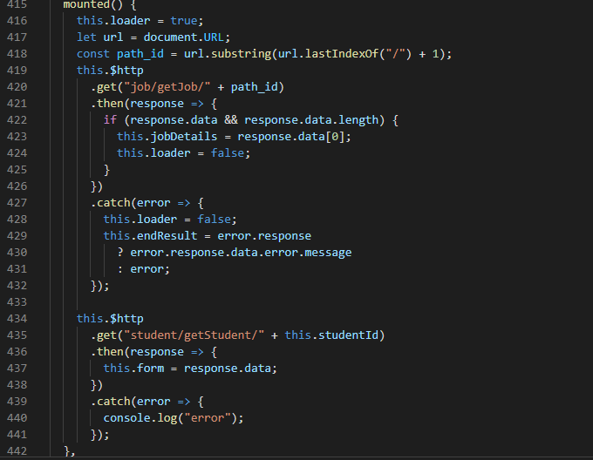

**Technical Manual – Yugandhar Rao Mamidi**

**Integrating LinkedIn UI:**

**Student View:**

All Registered users can login into their respective account and access student profile page and can enter their LinkedIn Url.

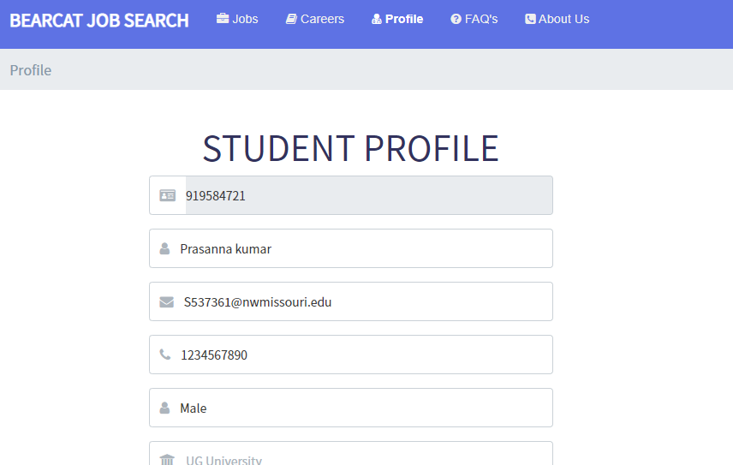

So, here they can insert or add their linkedin profile link or url and save their profile.

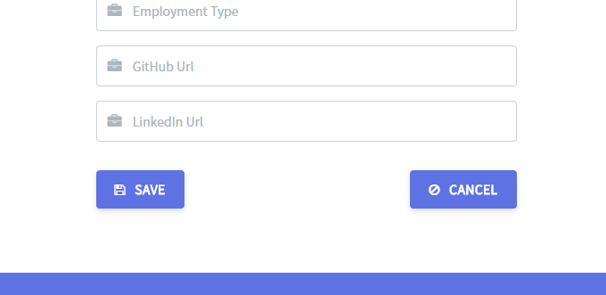

**Code Snippet for Student View:**

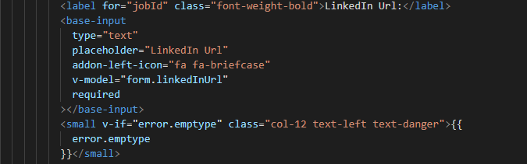

**Admin View:**

The Respective LinkedIn Url can be accessed by recruiters through their login and can navigate to the student LinkedIn profile directly

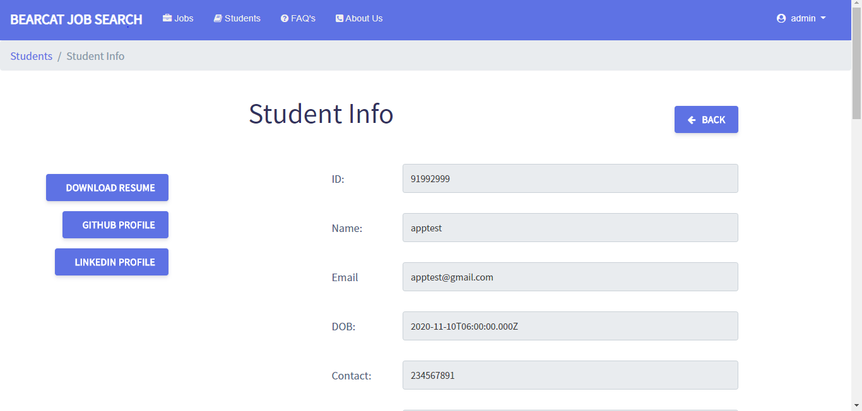

**Code Snippet for Admin View:**

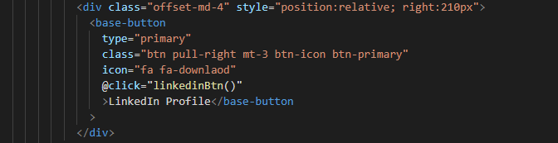

**Technical Manual - Santhosh Kumar Bollena**

* Integrating GitHub API
* Integrating GitHub UI

**Integrating GitHub API**

Whenever students provide their GitHub URL in their profile page our application will retrieve the information like projects that the students has done till now and display those projects in our application.

The project information contains the project title, description and the project link.

The integration to third party API form our application is done using the GitHub API’s

Code for GitHub API:

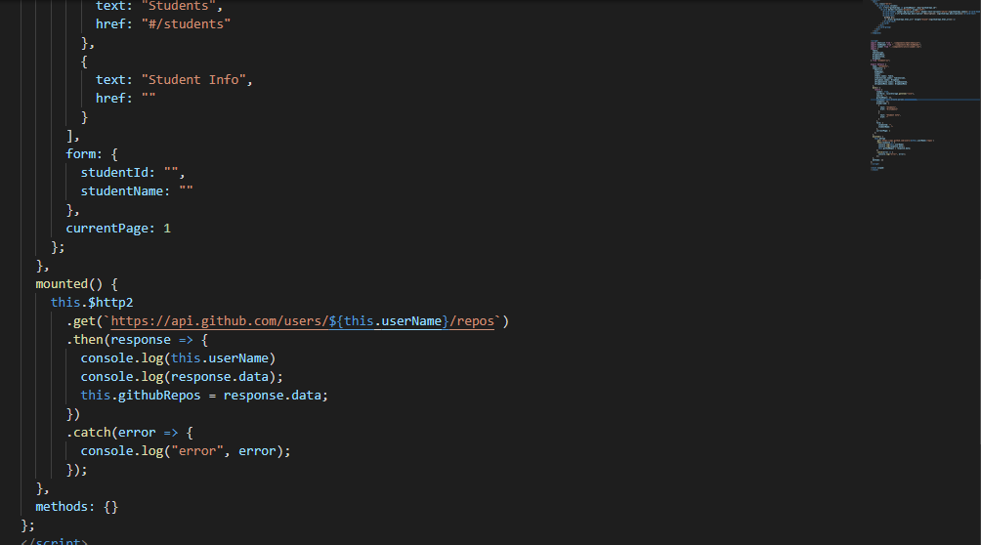

**Integrating GitHub UI.**

The GitHub projects information which is retrieved from the API is used by GitHub UI page to display the data.

The project information contains the project title, description and the project link where the recruiter or the admin can click on the link to redirect to the project information in GitHub.

Our Application has displayed the information in cards where a recruiter or the admin can understand easily.

Below Screenshot shows the student profile information and a recruiter or admin can click on GitHub button to show the GitHub projects information of the particular students.

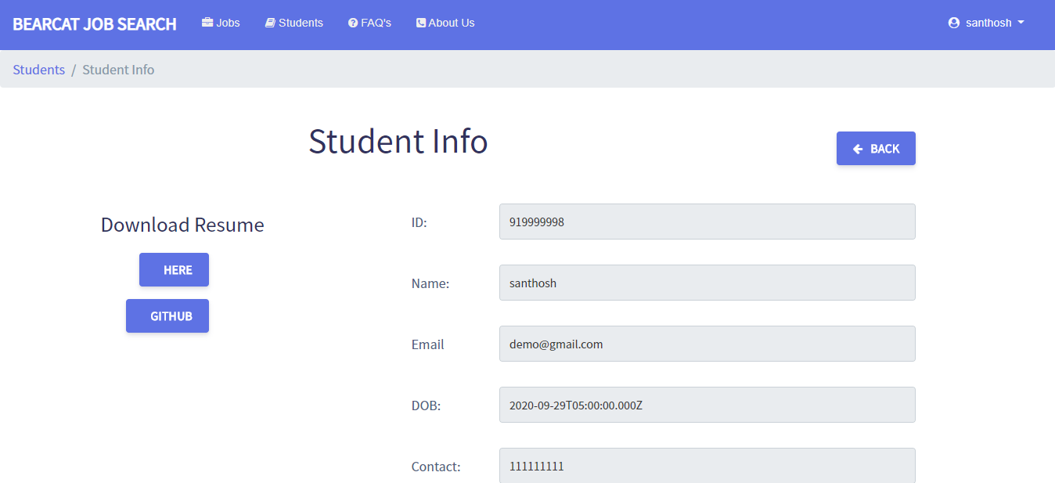

Below screenshot shows how our application will be displaying the third-party app GitHub information in cards view.

The recruiter or the admin can click on the project link to redirect to the GitHub project location.

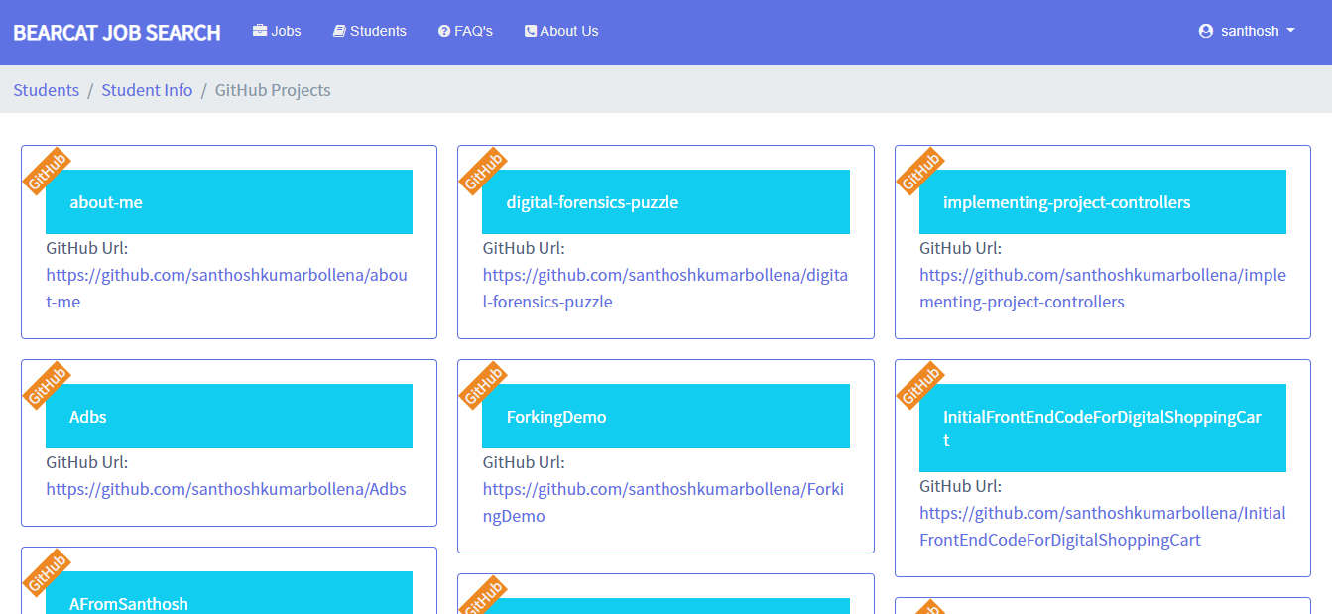

Whenever recruiter or admin click on the GitHub URL the user will be redirected to GitHub page.

Code for GitHub UI:

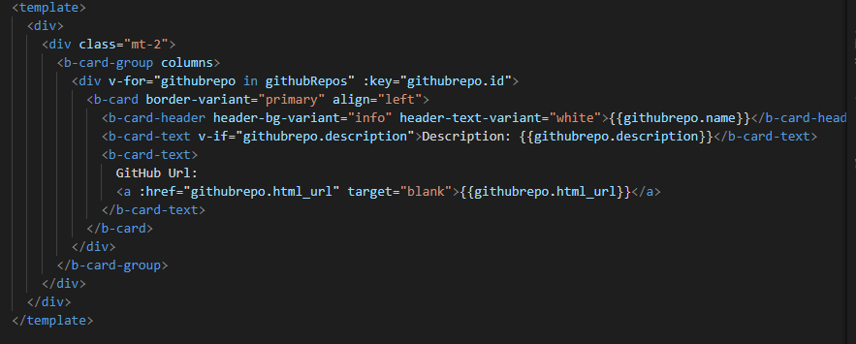

**Technical Manual – Anil Bomma**

* **Implementation of chat API**
* **Implementation of chat UI**

**This is the chatList.js page which contain all the functinalities required for the listing all chat users to admins. It contains all the templates that are used for the chart functinality.**

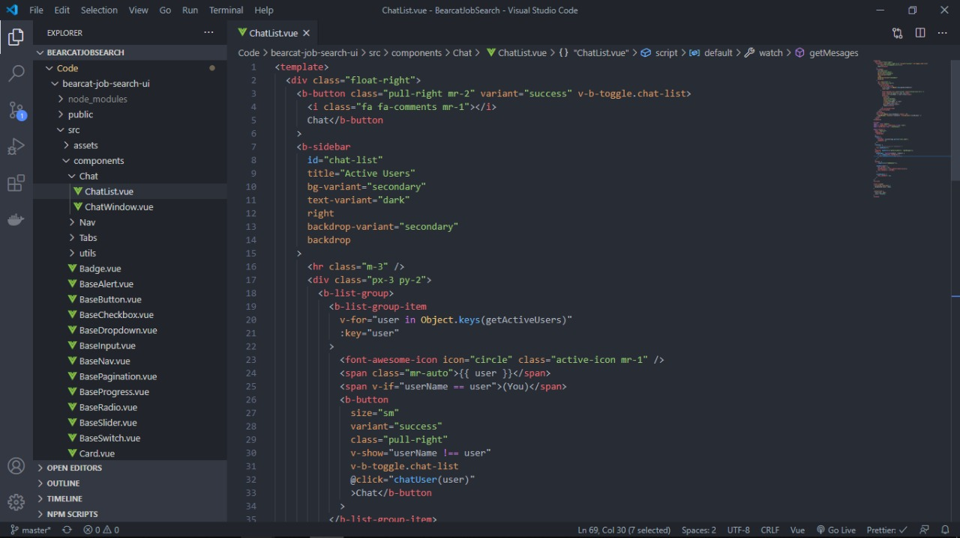

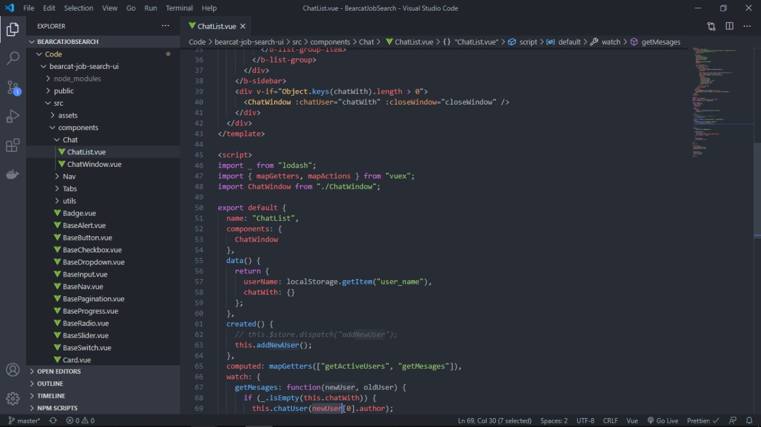

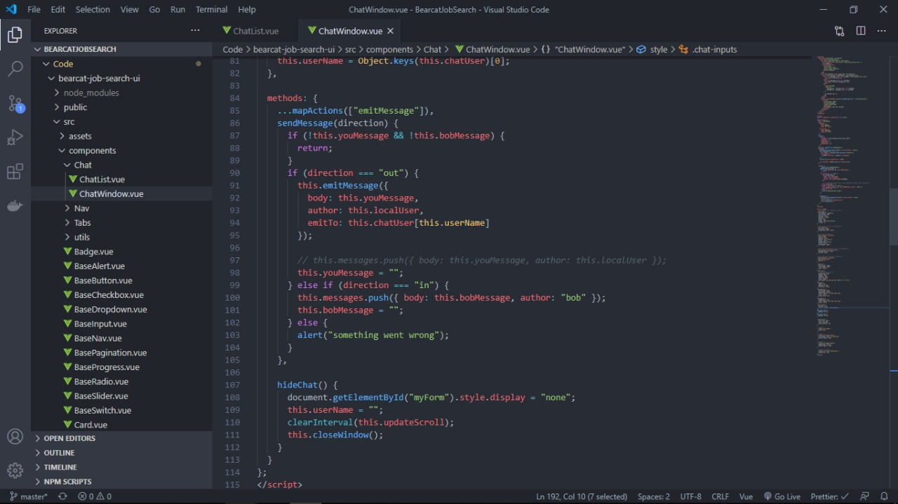

**This is the final outlook of the chat screen that is available to view.**

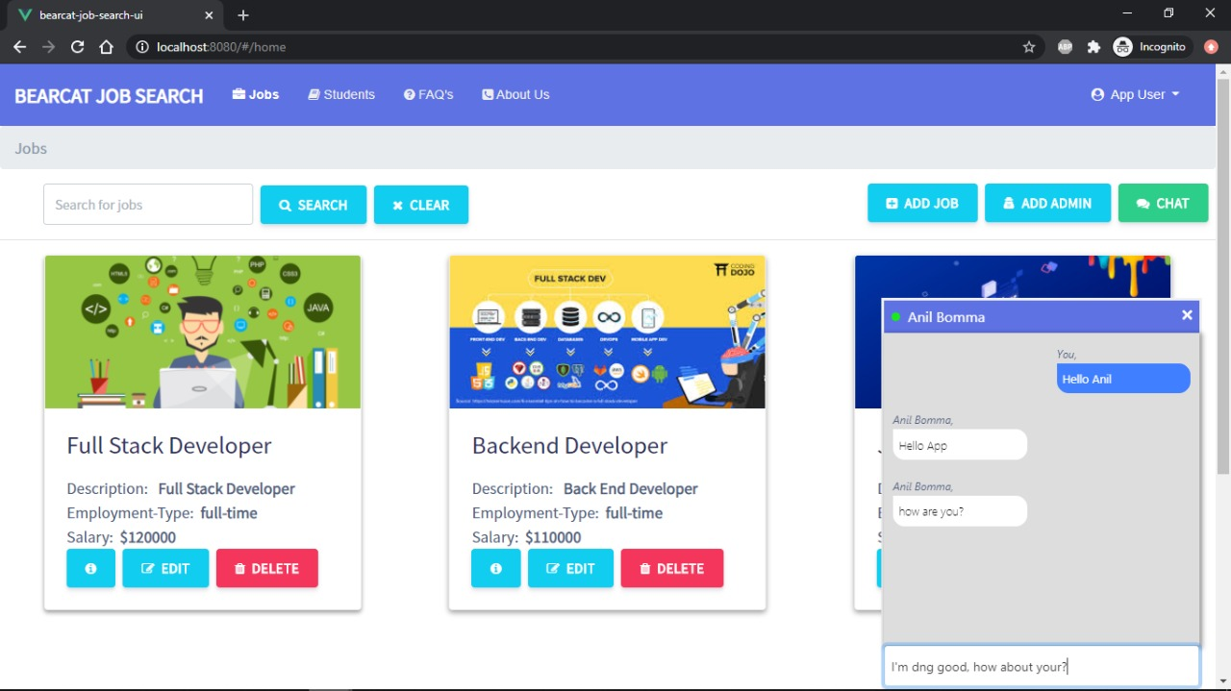

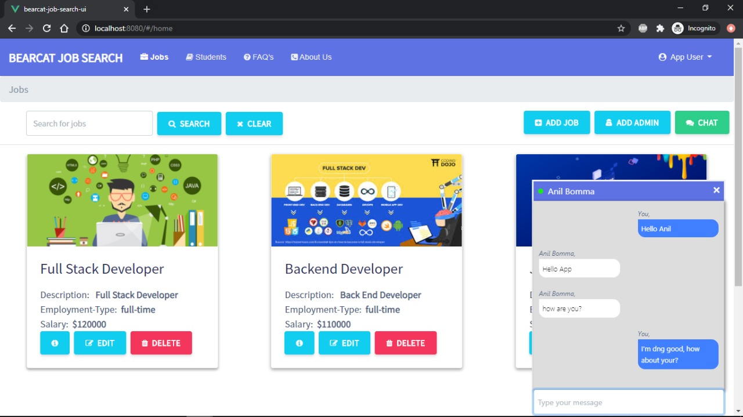

**Now lets see the back end part of the UI code of chat functionality:**

**This contain a method called ChatController which is used to get the data from the line which the user is sending and giving back the data to the user.**

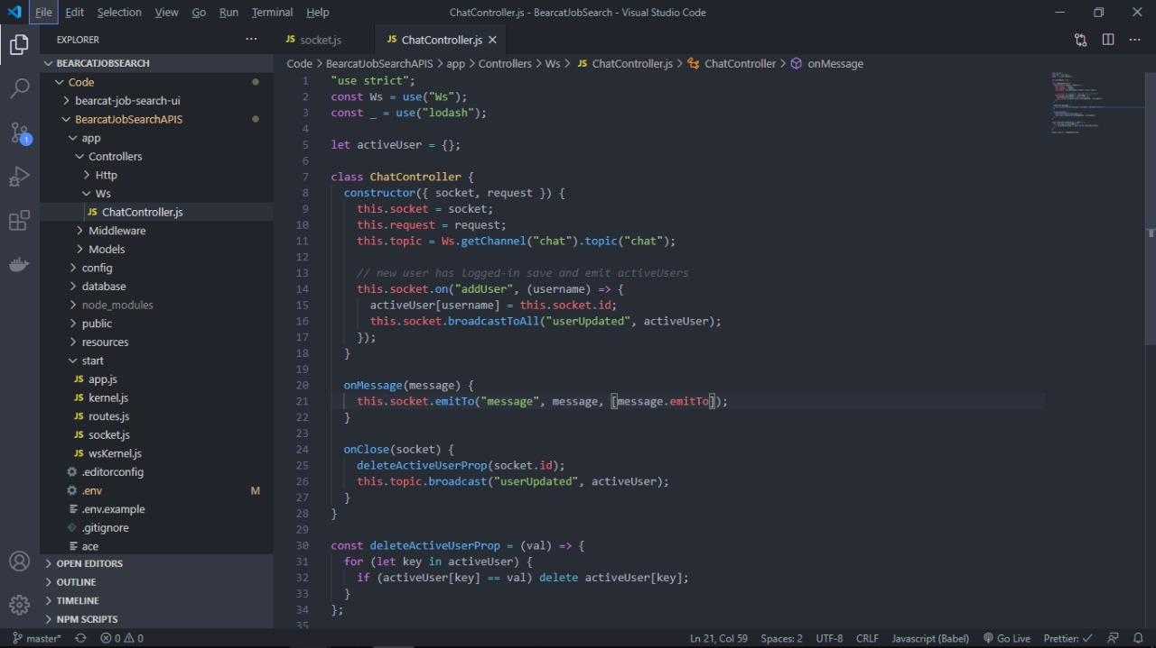

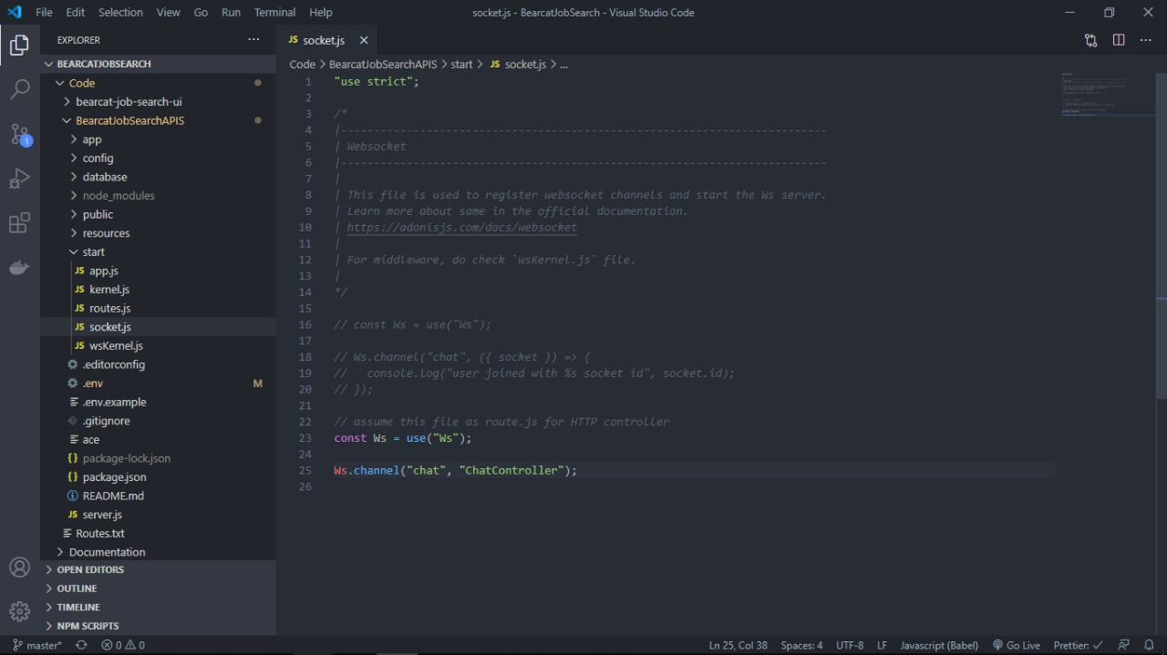

**Technical Manual – Mahender Reddy**

* Implementation of CRUD job post API
* Implementation of CRUD job post UI

Code for Implementing the CRUD operations of post API:

**Add jobs:**

This contain the AddJobs class which will have the functionality to add the entered job details into the database. Using the templates from Vue we have created the front end part and connected to database.

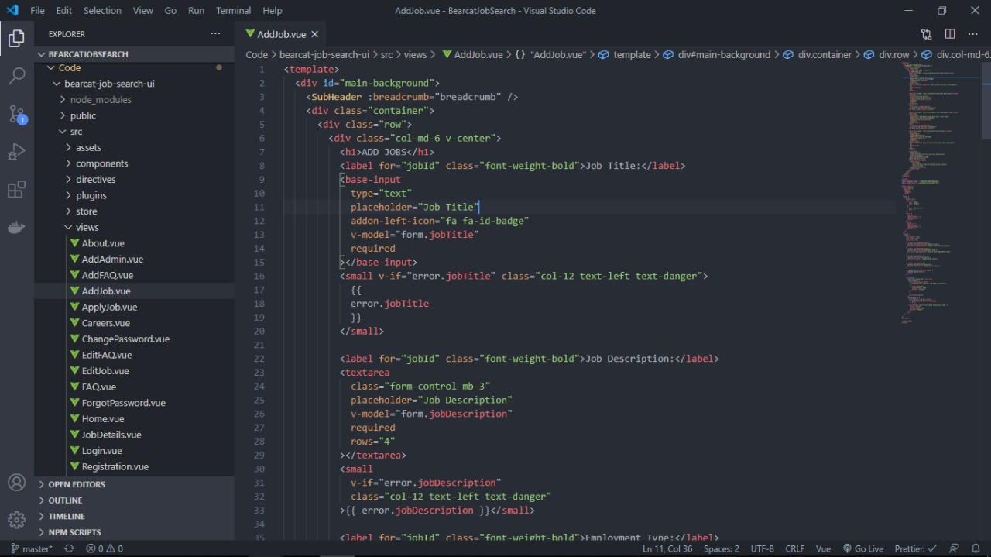

This is output screen of the Add job page.

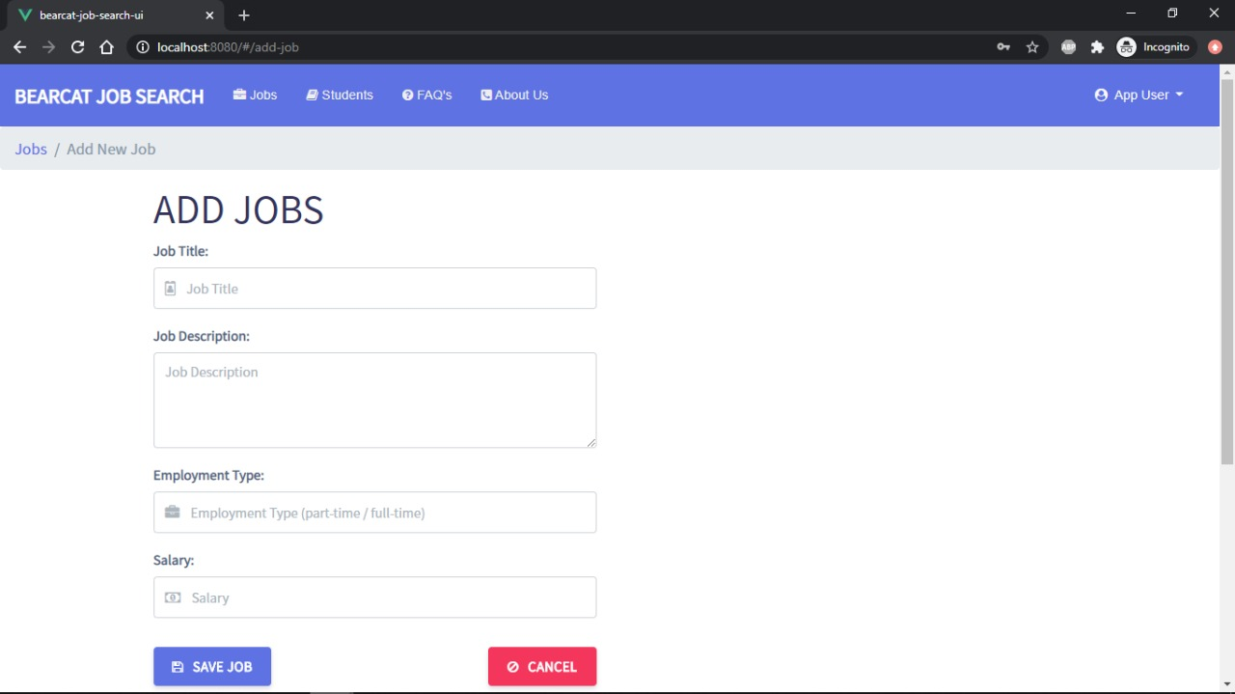

**Edit jobs:**

This code will help to edit the jobs that are already present in the database. The templates is used for the front end programming and we have used the view holders to place the objects in proper order.

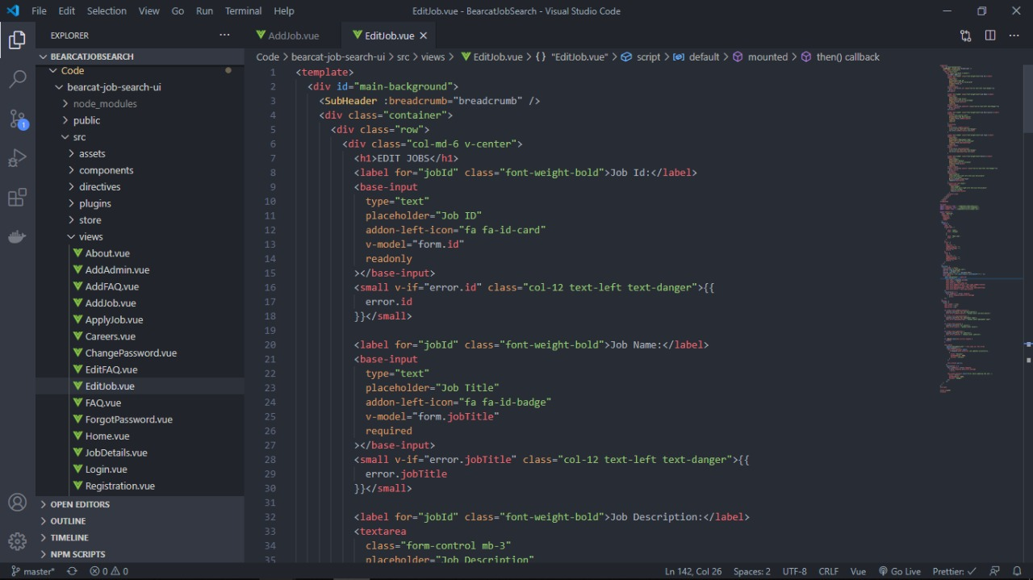

This is the output screen edit jobs page.

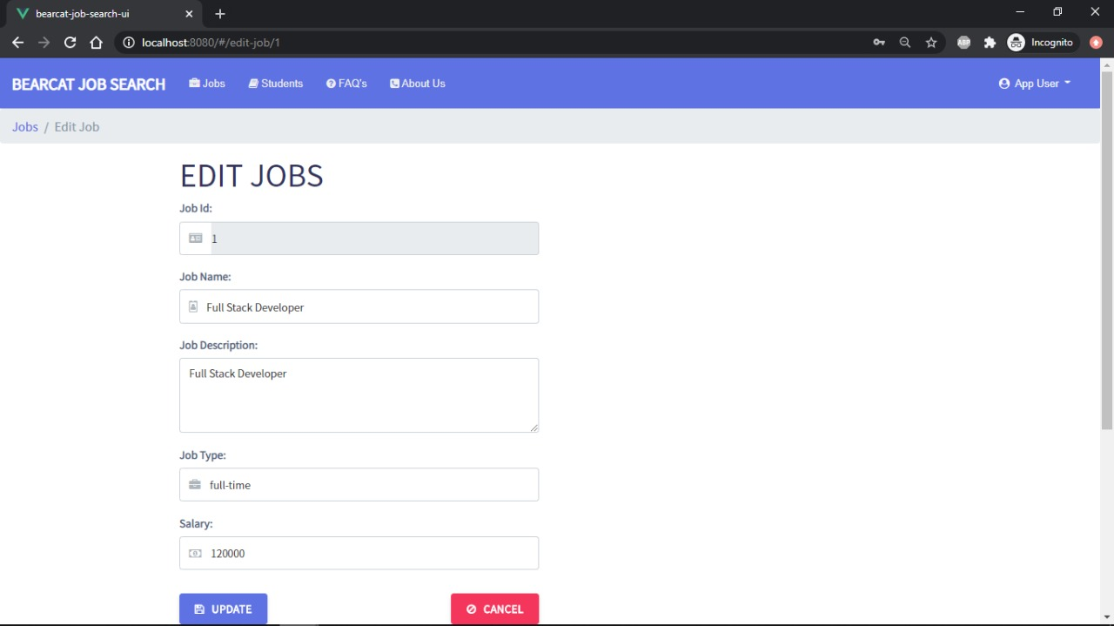

Updated Jobs portal:

This code is similar to the edit jobs page. We have used the place holders to call the objects and present them in places.



This is the output screen of update job portal.

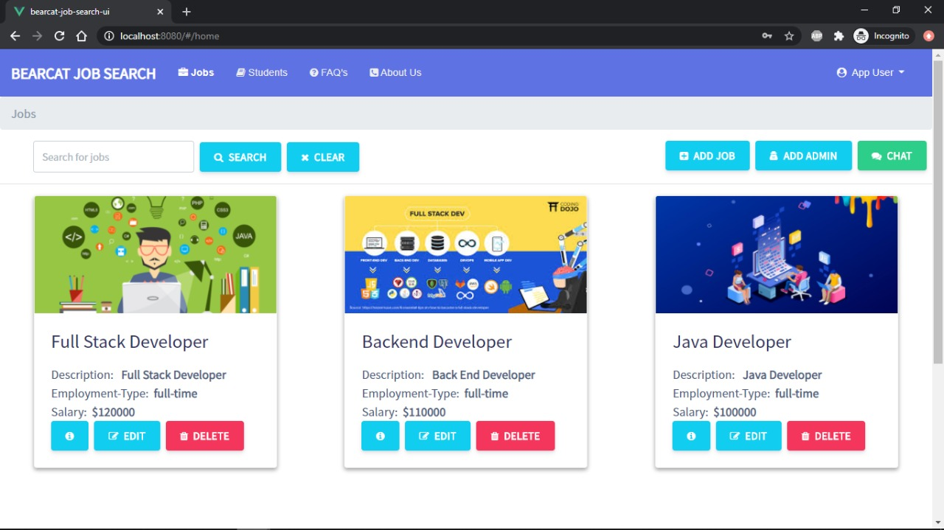

Creating the Jobs:

Using this page we can create a new job requirement according to the employer.

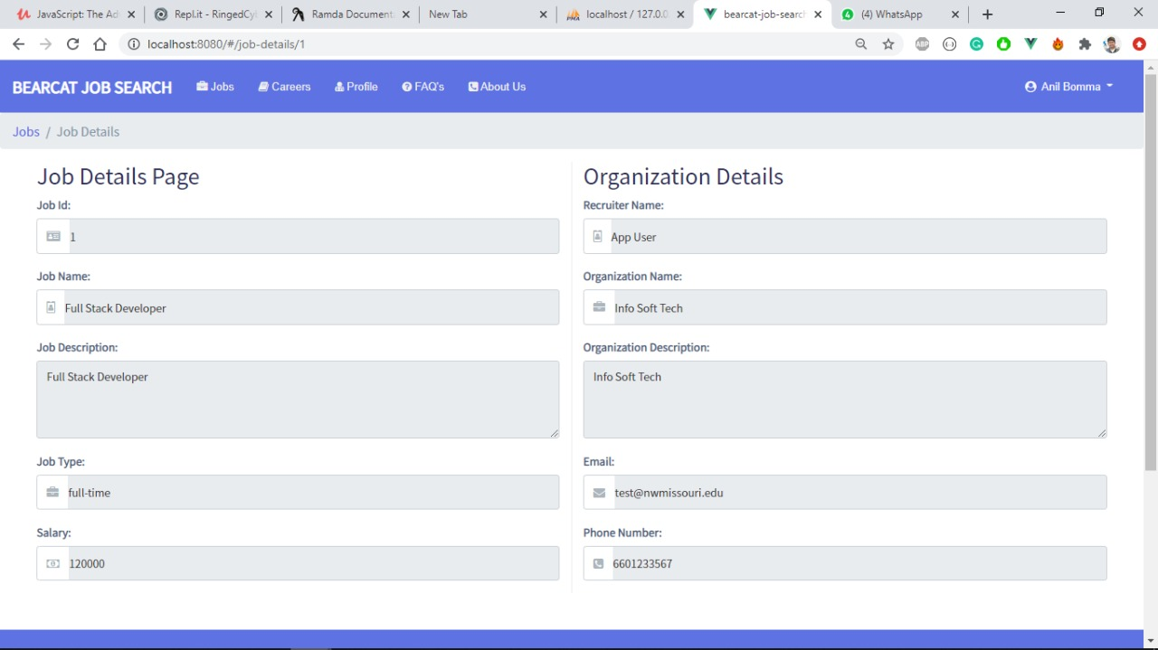

**CHAPTER 7**

**End-user Manual**

**7.1. Registration Page**

Here, we can see that, when the user enters all the required fields in the registration page, they will be alerted with a confirmation message.



We can see the alert box which is displaying the confirmation message, so that the user will be known the status of the registration

**7.2. Login Page**

This is a login page, where the user needs to enter the username and password in order to access the “home” page of the application



This is the home page where the user gets redirected, once their entered credentials gets valid

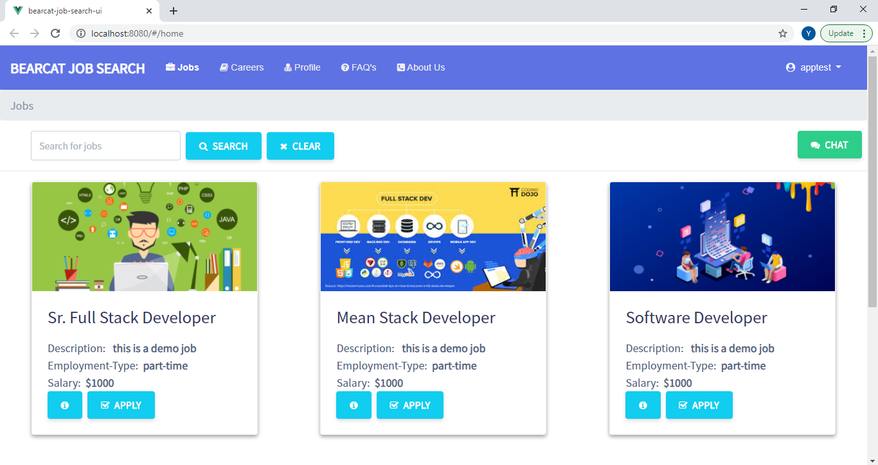

**7.3. Forgot Password Page**

If the user forgets their password they can navigate to this page and can enter their email id, so that email will be sent to their mail id as a confirmation link

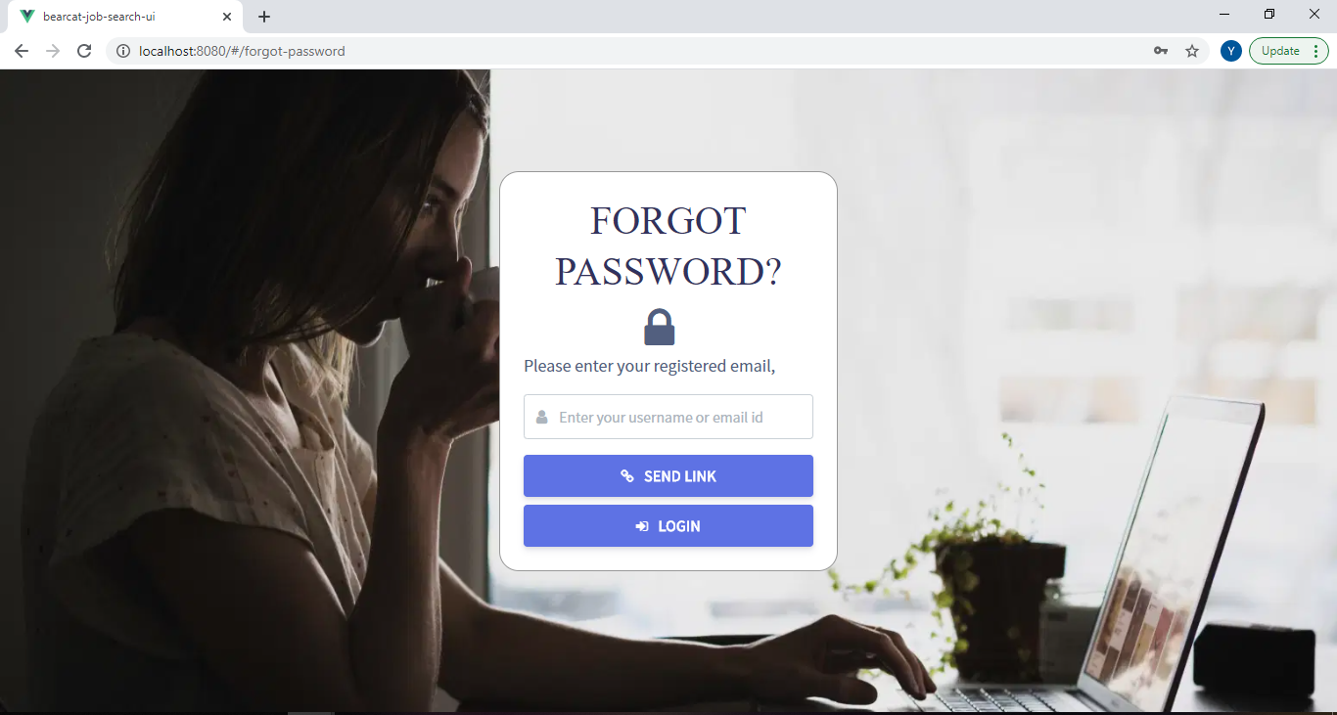

**7.4. Change Password Page**

If the user wants to change their password they can navigate to this change password page and can update the password

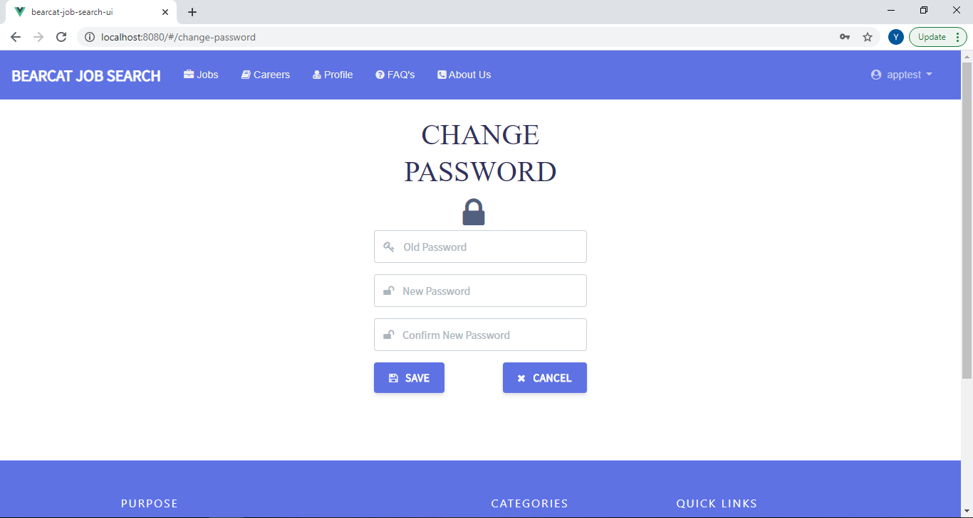

**End User Manual – Prasanna Kumar Potnuru**

* Sending mails
* Search Functionality UI

**Sending mails:**

If a student forgot password to login, they can change the same clicking on Forgot Password? link and they will be redirected to Forgot password link, where they need to enter registered email for the link through mail.





**Searching/Filtering Jobs, Applied jobs, FAQs:**

After a student’s successful login, they can find the Jobs in the navigation bar. For finding out a particular job based on Job name or description or some other filter quickly, they can search by entering the keyword.



Clicking on Search button will get the matching criteria or jobs and also they can clear the filter using Clear button as shown



**Search Jobs UI in Careers page:**

If a student applies a job, they can find all the applied jobs in the Careers option. For finding out a particular applied job based on Job name or description or some other filter quickly, they can search by entering the keyword.



**Search FAQs UI:**

If a student have a question, they can find all the frequently asked questions in FAQ’s page. For finding out a particular question based on a filter quickly, they can search by entering the keyword.



Clicking on Search button will get the matching criteria or questions and also they can clear the filter using Clear button as shown below.



**End User Manual –Sai Chandu Gampa**

* CRUD Apply Jobs API
* CRUD Apply Jobs UI

**Apply Jobs CRUD UI:** ThisCRUD involves the below tasks.

The student can apply to the available jobs in the Jobs page.Student can see the job description byclicking on “i”.





When the student clicks on the Apply button will be redirected to the following page.

If student want to cancel the applied job he can just click on “CANCEL” button.



**The student can see his profile while applying for the job and he can edit the information if necessary.**



**End User Manual – Yugandhar Rao Mamidi**

* Integrating LinkedIn UI

**Integrating LinkedIn UI:**

All Registered users can login into their respective account and access student profile page and can enter their LinkedIn Url.





When the admin clicks on the linked profile, the page redicts to linkedin profile of the student



**End User Manual - Santhosh Kumar Bollena**

* Integrating GitHub API
* Integrating GitHub UI

**Integrating GitHub API**

Whenever students provide their GitHub URL in their profile page our application will retrieve the information like projects that the students has done till now and display those projects in our application.

The project information contains the project title, description and the project link.

The integration to third party API form our application is done using the GitHub API’s

Code for GitHub API:



**End User manual - Santhosh**

**Integrating GitHub UI.**

The GitHub projects information which is retrieved from the API is used by GitHub UI page to display the data.

The project information contains the project title, description and the project link where the recruiter or the admin can click on the link to redirect to the project information in GitHub.

Our Application has displayed the information in cards where a recruiter or the admin can understand easily.

Below Screenshot shows the student profile information and a recruiter or admin can click on GitHub button to show the GitHub projects information of the particular students.



Below screenshot shows how our application will be displaying the third-party app GitHub information in cards view.

The recruiter or the admin can click on the project link to redirect to the GitHub project location.



Whenever recruiter or admin click on the GitHub URL the user will be redirected to GitHub page.

Code for GitHub UI:



**End user manual - Anil Bomma**

**When we open the chat window it appears as follows and we can enter data in the chat that will reflect to the admin and the reply can be given to the end user.**

**This is the place where the admin can view all the active users present in the website.**

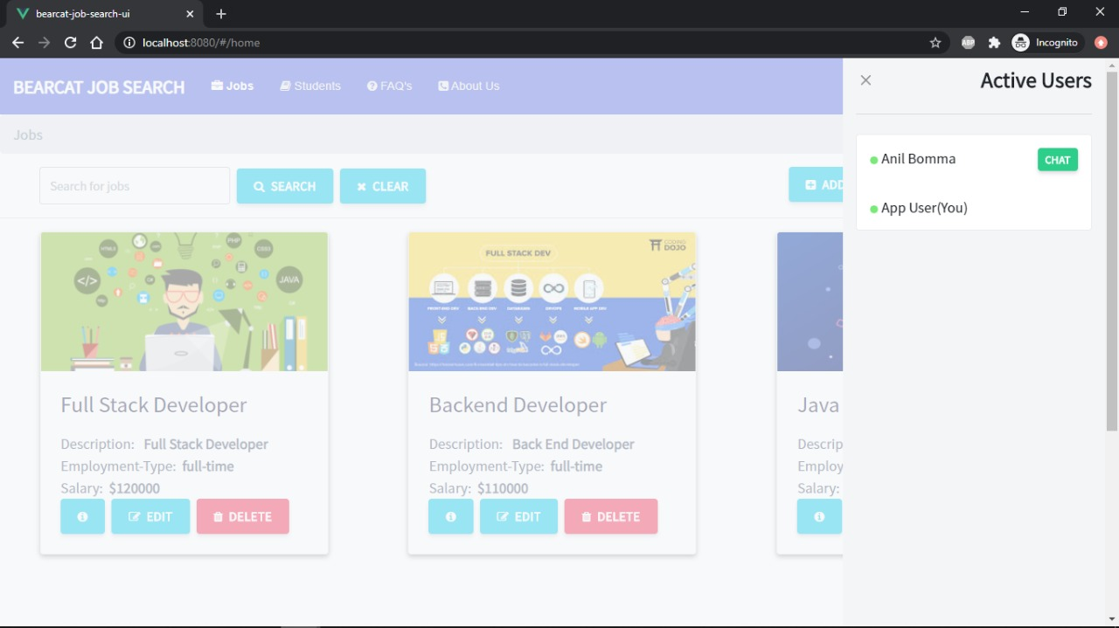

**By clicking on the user name a new window will appear as shown in the website.**



**What evenr we type as admin will appear in the users portal as shown in the picture of the website.**



**End User Manual by Mahender :**

**Add jobs page:**

Using this page, we can add new jobs. After entering all the job details, the job is save in th database and that will appear in he jobs list.



**Edit jobs page:**

Using this page, we can edit already present jobs. This changes will reflect in database.



**Edited Jobs Page:**

Here, we can view the updated job in the home page.



**Create jobs page:**

Using this page, we can create a new job according to the requirements specified by the employer. After entering all details, we can click on submit that will create a new job according to the requirements.

